**Participant Initiated Non-RID Activities**

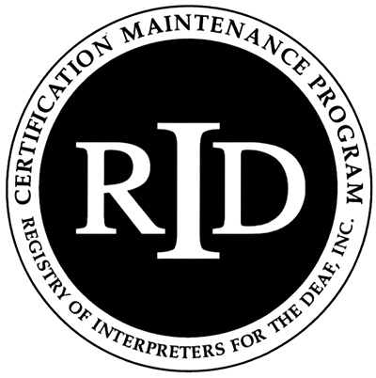

**(PINRA)**

This form will be used if an RID member plans to attend another organization’s workshop, conference, formal in-service training or activity. The RID Approved Sponsor will determine if the activity is appropriate for CEUs.

**Before the start of the activity/conference, this section must be filled out**

**and signed by both the participant and RID Approved Sponsor:**

Participant Name: RID Member #:

Participant Address:

Email: Phone #:

Activity/Conference Name:

Activity/Conference Theme or Focus (attach brochure/flier)

Date and Times of activities you will attend:

Total number of CEUs to be awarded:

**Circle** content area: Professional Studies General Studies

I certify that this activity/conference represents a valid and verifiable Continuing Education Experience that exceeds

routine employment responsibilities.

Participant Signature: . Date:

===========================================================================

Name and Code of RID Approved Sponsor: Kentucky Registry of Interpreters for the Deaf

I certify that I received this activity plan prior to the start of the activity/conference and I agree to sponsor this Continuing Education Experience. I will verify successful completion prior to awarding CEUs.

RID Sponsor Administrator Name:  Signature:

RID Sponsor Code: **0048**  Date:

**This section must be filled out and signed upon *completion* of the activity/conference:**

Activity Code Number Click here to enter text. CEUs Awarded: Click here to enter text.

I have verified that the participant attended this activity/conference and that the activities listed are appropriate educational experiences which should be awarded the number of CEUs denoted above.

RID Approved Sponsor Signature Administrator: Click here to enter text.Date: Click here to enter a date.

**The Participant must send documentation of attendance to the Sponsor upon completion of the activity. The Sponsor must file this form with RID online at myaccount.rid.org within 45 days of the completion of the activity/conference.**